Assignment 6.1

TASK 1:
Use AI to create an Employee class with attributes (name,
id, salary) and a method to calculate yearly salary.
• Instructions:
o Prompt AI to generate the Employee class.
o Analyze the generated code for correctness and structure.
o Ask AI to add a method to give a bonus and recalculate
salary
PROMPT :
create Employee class with attributes (name, id, salary) and a method to calculate yearly salary and add a method to give bouns and recalculate the salary
CODE AND OUTPUT :
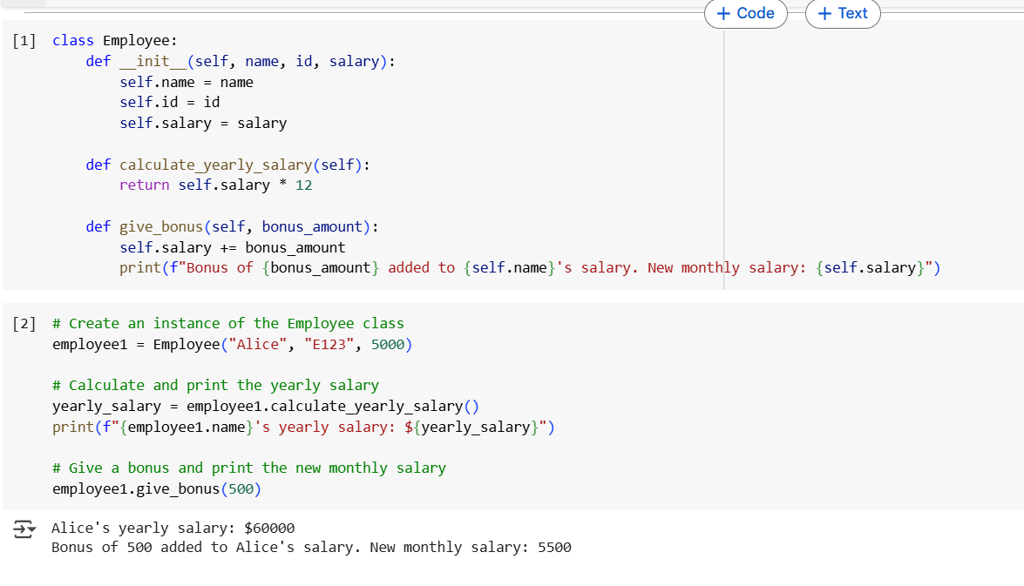
TASK 2 :
Prompt AI to generate a function that displays all
Automorphic numbers between 1 and 1000 using a for loop.
• Instructions:
o Get AI-generated code to list Automorphic numbers using
a for loop.
o Analyze the correctness and efficiency of the generated
logic.
o Ask AI to regenerate using a while loop and compare both
implementations
PROMPT :
write a python function to generate a function that displays all Automorphic numbers between 1 and 1000 using a for loop and regenerate using a while loop and compare both implementations
CODE AND OUTPUT :
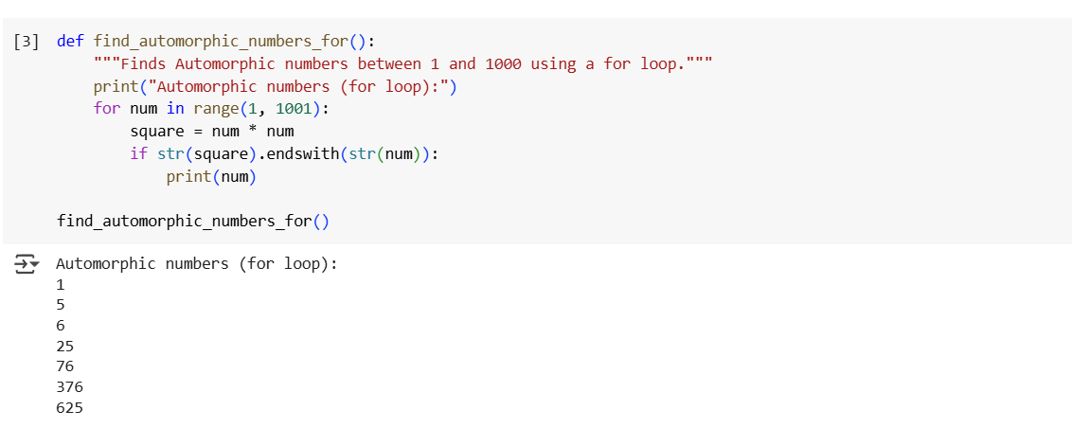
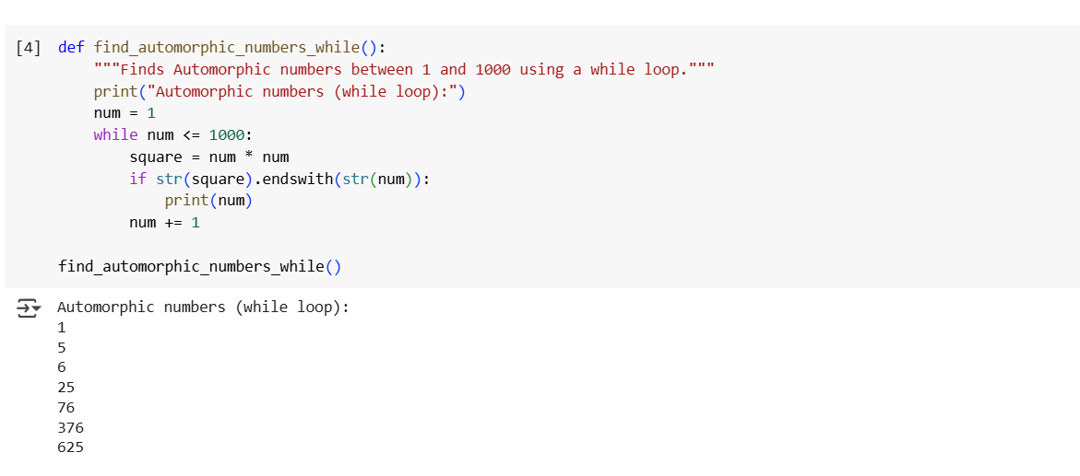
OBSERVATIONS :
- Both the for loop and while loop implementations successfully identified the Automorphic numbers between 1 and 1000 as 1, 5, 6, 25, 76, 376, and 625.
- For this specific task with a known number of iterations (1 to 1000), both for and while loops are suitable.
- The for loop implementation is more concise and generally considered more "Pythonic" for iterating over a fixed range or sequence as it handles initialization, condition checking, and incrementing implicitly.
- The while loop provides more explicit control over the loop's execution flow but requires manual management of the loop variable (initialization, condition, increment).

TASK 3 :
Ask AI to write nested if-elif-else conditions to classify
online shopping feedback as Positive, Neutral, or Negative based
on a numerical rating (1–5).
• Instructions:
o Generate initial code using nested if-elif-else.
o Analyze correctness and readability.
o Ask AI to rewrite using dictionary-based or match-case
structure.
PROMPT :
write a python function of nested if-elif-else conditions to classify online shopping feedback as Positive, Neutral, or Negative based on a numerical rating and rewrite using dictionary-based or match-case structure.
CODE AND OUTPUT :
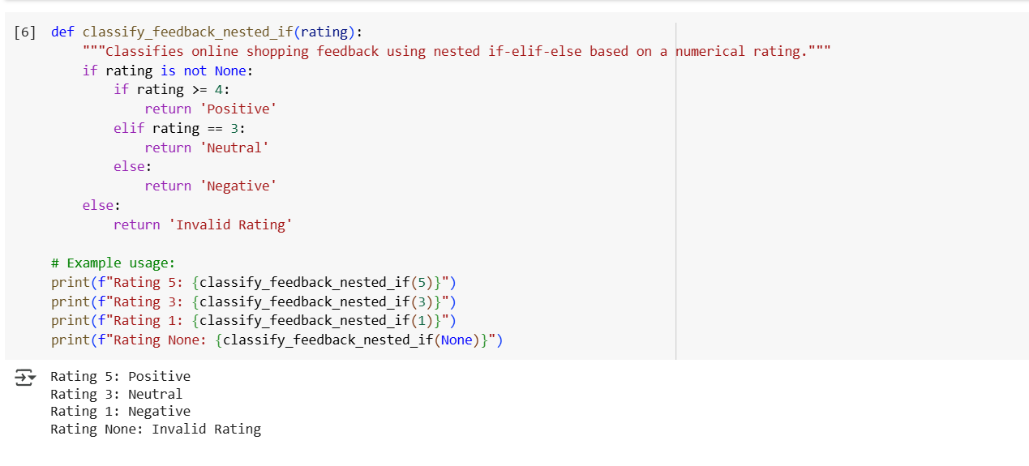
OBSERVATIONS :
- The classify_feedback_nested_if function successfully classifies ratings: 5 as 'Positive', 3 as 'Neutral', 1 as 'Negative', and 'None' as 'Invalid RatinG
- The classify_feedback_dict_match function accurately classifies valid integer ratings (1-5) and correctly identifies non-integer or out-of-range inputs as 'Invalid Rating'.
- After modifying the classify_feedback_nested_if function to include input type validation, both functions produced identical classification results for a diverse set of test inputs.
- For this specific task, the dictionary-based approach is considered more readable and maintainable due to its clear mapping of ratings to classifications, compared to the sequential conditional checks of the if-elif-else structure.
- The performance difference between the two approaches is negligible for this task scale.

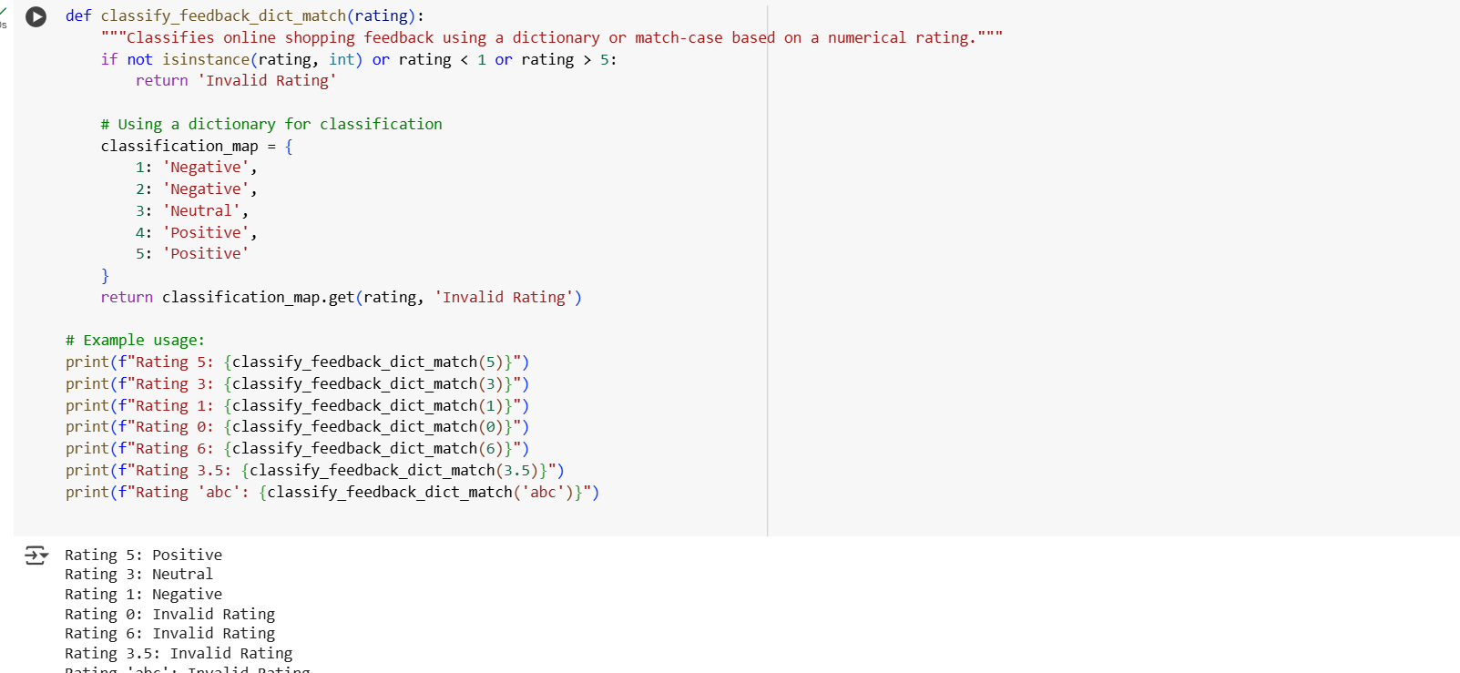
TASK 4 :
Generate a function using AI that displays all prime
numbers within a user-specified range (e.g., 1 to 500).
• Instructions:
o Get AI-generated code to list all primes using a for loop.
o Analyze the correctness and efficiency of the prime-
checking logic.
o Ask AI to regenerate an optimized version (e.g., using the
square root method
PROMPT :
write a python function using loops that displays all prime numbers within a range 1 to 500 and regenerate using the square root method
CODE AND OUTPUT :
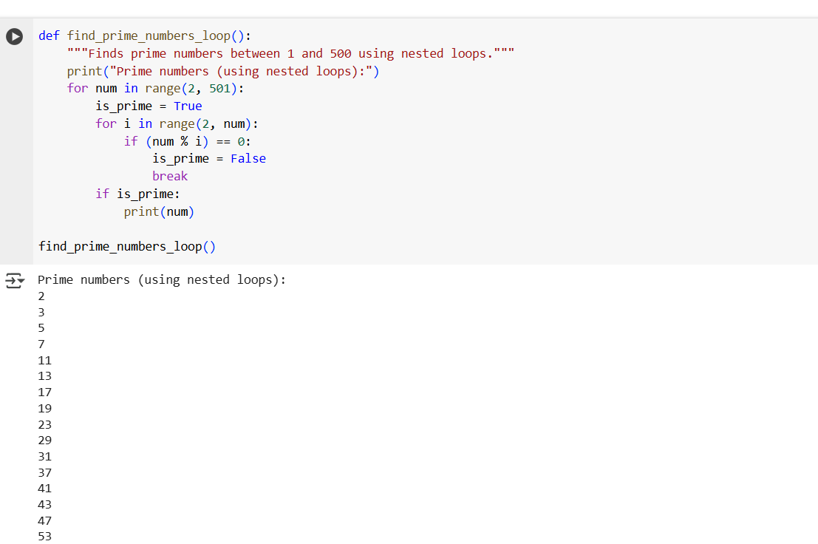


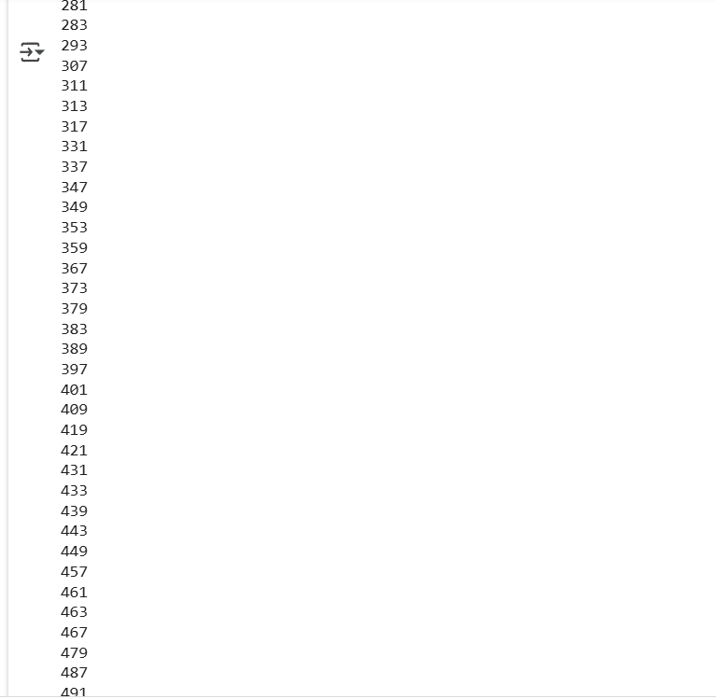

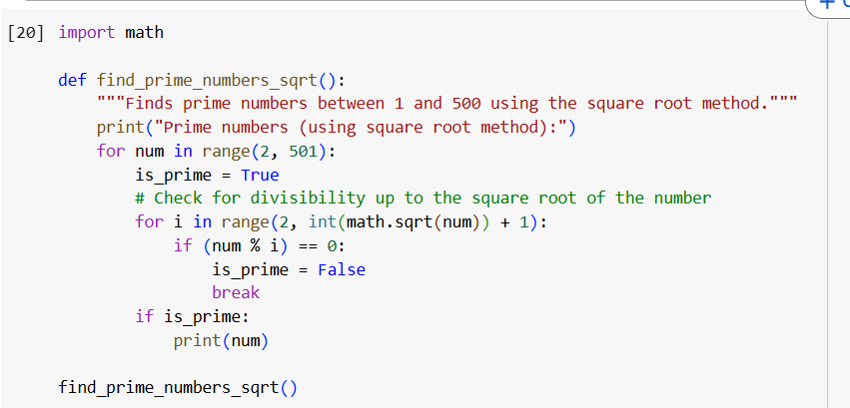

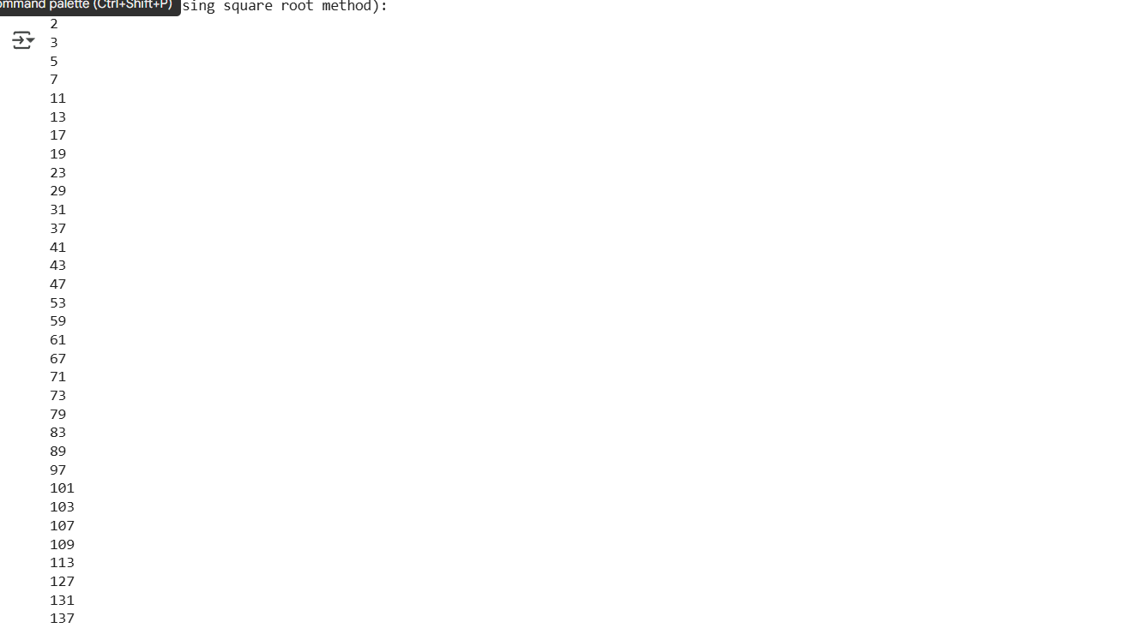

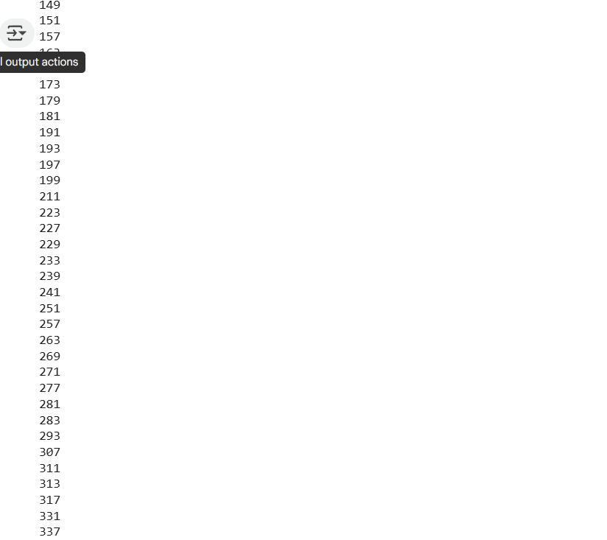

TASK 5 :
Use AI to build a Library class with methods to
add_book(), issue_book(), and display_books().
• Instructions:
o Generate Library class code using AI.
o Analyze if methods handle edge cases (e.g., issuing
unavailable books).
o Ask AI to add comments and documentation
PROMPT :
write a python function to build a Library class with methods to add_book(), issue_book(), and display_books() and add comments and documentation
CODE AND OUTPUT :
